**A MINOR PROJECT REPORT**

**ON AIR POLLUTION MONITORING SYSTEM**

*A Dissertation Submitted*

*In partial fulfillment of the requirements of*

**BACHELOR OF TECHNOLOGY**

**IN**

**INFORMATION TECHNOLOGY**

**BY**

**Baddam Abhinaya Reddy 20BK1A1209**

**Gannu Prasanna Reddy 20BK1A12B6**

**Under the Esteemed Guidance of**

**Mrs.K.Madhavi , M. Tech**

**(Ph.D) Associate Professor**



**DEPARTMENT OF INFORMATION TECHNOLOGY**

**St.PETER’S ENGINEERING COLLEGE(UGC Autonomous)**

**Maisammaguda, Dulapally, Rangareddy(Dist.) - 500100 (TS)**

**(Affiliated to JNTU and approved by A.I.C.T.E)**

**2020-2024**

**INDEX**

**LIST OF CONTENTS Page No**

**ACKNOWLEDGEMENT i**

**ABSTRACT ii**

**1.INTRODUCTION 01-06**

1.1 General Introduction 01-05

1.1.1 IOT (Internet of Things) 01

1.1.2 IOT-Key Features 01

1.1.3 IOT-Advantages 02

1.2 IOT-Disadvantages 03

1.3 IOT Software 03-04

1.4. Internet of Things 04-06

1. **LITERATURE SURVEY**
2. **07-09** 
   1. Literature Review 08-09
3. **EXISTING SYSTEM AND PROPOSED SYSTEM 10-12** 
   1. Existing system 11
      1. Disadvantages of Existing System 11
   2. Proposed system 11-12
   3. Advantages of Proposed System 12
4. **ANALYSIS 13-15** 
   1. Purpose of project 14
   2. System Requirements Specifications 15
      1. Hardware requirements 15
      2. Software requirements 15
5. **SYSTEM DESIGN 16-18** 
   1. Introduction 17
   2. Data flow Diagram 18
6. **IMPLEMENTATION 19-29** 
   1. Uploading code to Arduino 20-24
   2. Hardware Connections 24-29
7. **CODE 30-31**
8. **TESTING 32-33**
9. **CONCLUSION 34**
10. **FUTURE ENHANCEMENT 34**
11. **REFERENCES 35**

**1.1 GENERAL INTRODUCTION**

**1.1.1IOT (Internet of Things)**

IOT (Internet of Things) is an advanced automation and analytics system which exploits networking, sensing, big data, and artificial intelligence technology to deliver complete systems for a product or service.

These systems allow greater transparency, control, and performance when applied to any industry or system. IOT systems have applications across industries through their unique flexibility and ability to be suitable in any environment. They enhance data collection, automation, operations, and much more through smart devices and powerful enabling technology.

**1.1.2 IOT − Key Features**

The most important features of IOT include artificial intelligence, connectivity, sensors, active engagement, and small device use. A brief review of these features is given below

AI − IOT essentially makes virtually anything “smart”, meaning it enhances every aspect of life with the power of data collection, artificial intelligence algorithms, and networks. This can mean something as simple as enhancing your refrigerator and cabinets to detect when milk and your favorite cereal run low, and to then place an order with your preferred grocer.

Connectivity − New enabling technologies for networking, and specifically IOT networking, mean networks are no longer exclusively tied to major providers. Networks can exist on a much smaller and cheaper scale while still being practical. IOT creates these small networks between its system devices.

Sensors − IOT loses its distinction without sensors. They act as defining instruments which transform IOT from a standard passive network of devices into an active system capable of real-world integration.

Active Engagement − Much of today's interaction with connected technology happens through passive engagement. IOT introduces a new paradigm for active content, product, or service engagement.

Small Devices − Devices, as predicted, have become smaller, cheaper, and more powerful over time. IOT exploits purpose-built small devices to deliver its precision, scalability, and versatility.

**1.1.3 IOT − Advantages**

Advantages of IOT span across every area of lifestyle and business. Here is a list of some of the advantages that IOT has to offer.

Improved Customer Engagement − Current analytics suffer from blind-spots and significant flaws in accuracy; and as noted, engagement remains passive. IOT completely transforms this to achieve richer and more effective engagement with audiences.

Technology Optimization − The same technologies and data which improve the customer experience also improve device use, and aid in more potent improvements to technology. IOT unlocks a world of critical functional and field data.

Reduced Waste − IOT makes areas of improvement clear. Current analytics give us superficial insight, but IOT provides real-world information leading to more effective management of resources.

Enhanced Data Collection − Modern data collection suffers from its limitations and its design for passive use. IOT breaks it out of those spaces, and places it exactly where humans really want to go to analyses our world. It allows an accurate picture of everything.

**1.2 IOT Disadvantages**

Though IOT delivers an impressive set of benefits, it also presents a significant set of challenges. Here is a list of some its major issues

Security – IOT creates an ecosystem of constantly connected devices communicating over networks. The system offers little control despite any security measures. This leaves users exposed to various kinds of attackers.

Privacy – The sophistication of IOT provides substantial personal data in extreme detail without the user’s active participation.

Complexity – Some find IOT systems complicated in terms of design, deployment, and maintenance given their use of multiple technologies and a large set of new enabling technologies.

Flexibility – Many are concerned about the flexibility of an IOT system to integrate easily with another.

They worry about finding themselves with several conflicting or locked systems.

Compliance – IOT, like any other technology in the realm of business, must comply with regulations. Its complexity makes the issue of compliance seem incredibly challenging when many consider standard software compliance a battle.

**1.3 IOT Software**

software addresses its key areas of networking and action through platforms, embedded systems, partner systems, and middleware.

These individual and master applications are responsible for data collection, device integration, realtime analytics, and application and process extension within the IOT network.

They exploit integration with critical business systems (e.g., ordering systems, robotics, scheduling, and more) in the execution of related tasks.

Data Collection

This software manages sensing, measurements, light data filtering, light data security, and aggregation of data.

It uses certain protocols to aid sensors in connecting with real-time, machine-to-machine networks. Then it collects data from multiple devices and distributes it in accordance with settings.

It also works in reverse by distributing data over devices. The system eventually transmits all collected data to a central server.

Device Integration

Software supporting integration binds (dependent relationships) all system devices to create the body of the IOT system. It ensures the necessary cooperation and stable networking between devices. These applications are the defining software technology of the IOT network because without them, it is not an IOT system. They manage the various applications, protocols, and limitations of each device to allow communication.

Real-Time Analytics

These applications take data or input from various devices and convert it into viable actions or clear patterns for human analysis. They analyze information based on various settings and designs in order to perform automation-related tasks or provide the data required by industry.

Application and Process Extension

These applications extend the reach of existing systems and software to allow a wider, more effective system. They integrate predefined devices for specific purposes such as allowing certain mobile devices or engineering instruments access. It supports improved productivity and more accurate data collection.

**1.4 Internet of Things**

Technology and Protocols IOT primarily exploits standard protocols and networking technologies. However, the major enabling technologies and protocols of IOT are RFID, NFC, lowenergy Bluetooth, low-energy wireless, low-energy radio protocols, LTE-A, and Wi Fi-Direct.

These technologies support the specific networking functionality needed in an IOT system in contrast to a standard uniform network of common systems.

NFC and RFID

RFID (radio-frequency identification) and NFC (near-field communication) provide simple, low energy, and versatile options for identity and access tokens, connection bootstrapping, and payments.

RFID technology employs 2-way radio transmitter-receivers to identify and track tags associated with objects.

NFC consists of communication protocols for electronic devices, typically a mobile device and a standard device.

Low-Energy Bluetooth

This technology supports the low-power, long-use need of IOT function while exploiting a standard technology with native support across systems.

Low-Energy Wireless

This technology replaces the most power-hungry aspect of an IOT system. Though sensors and other elements can power down over long periods, communication links (i.e., wireless) must remain in listening mode. Low-energy wireless not only reduces consumption, but also extends the life of the device through less use.

Radio Protocols ZigBee, Z-Wave, and Thread are radio protocols for creating low-rate private area networks. These technologies are low-power, but offer high throughput unlike many similar options. This increases the power of small local device networks without the typical costs.

LTE-A or LTE Advanced, delivers an important upgrade to LTE technology by increasing not only its coverage, but also reducing its latency and raising its throughput.

It gives IOT a tremendous power through expanding its range, with its most significant applications being vehicle, UAV, and similar communication.

13 Wi-Fi-Direct eliminates the need for an access point. It allows P2P (peer-to-peer) connections with the speed of Wi-Fi, but with lower latency. Wi-Fi-Direct eliminates an element of a network that often bogs it down, and it does not compromise on speed or throughput.

Common Uses IOT has applications across all industries and markets. It spans user groups from those who want to reduce energy use in their home to large organizations who want to streamline their operations.

It proves not just useful, but nearly critical in many industries as technology advances and we move towards the advanced automation imagined in the distant future. Engineering, Industry, and Infrastructure Applications of IOT in these areas include improving production, marketing, service delivery, and safety.

IOT provides a strong means of monitoring various processes; and real transparency creates greater visibility for improvement opportunities. The deep level of control afforded by IOT allows rapid and more action on those opportunities, which include events like obvious customer needs, nonconforming product, malfunctions in equipment, problems in the distribution network, and more.

The technology fills in the current gaps, corrects many current flaws, and expands the reach of these efforts. For example, IOT can help city planners have a clearer view of the impact of their design, and governments have a better idea of the local economy.

Home and Office In our daily lives, IOT provides a personalized experience from the home to the office to the organizations we frequently do business with. This improves our overall satisfaction, enhances productivity, and improves our health and safety.

For example, IOT can help us customize our office space to optimize our work. Health and Medicine IOT push us towards our imagined future of medicine which exploits a highly integrated network of sophisticated medical devices.

Today, IOT can dramatically enhance medical research, devices, care, and emergency care. The integration of all elements provides more accuracy, more attention to detail, faster reactions to events, and constant improvement.

**2.1 LITERATURE REVIEW**

Pollution is increasing in an alarming rate every day. Air is the most sensitive element of the environment which is polluted momentarily by the elements emitted to air. To know the level of air pollution and air quality this proposed system is a wireless sensor network that works mainly monitoring the pollution happening in a smart city. It is a low budget monitoring system with cheap but efficient sensors. Some previous works like Smart environment monitoring system [1] on vehicles was introduced on 2015. It basically figured out the emission rate of poisonous gasses which are responsible for air pollution. Industrial air pollution [2] monitoring system for safety and health enhancement was introduced to know the hazardous gasses and their impact. Low-cost air quality system [3] was discussed on 2008 as because at that time the sensors were quite expensive and also the system. By using mobile GPRS [4] system air pollution could be detected.

Wireless sensor network-based pollution monitoring system in metropolitan cities was introduced to know the air quality [5]. Pollution Dynamic Monitoring System [6] is also done previously. By reviewing the future researches which has done before we can say that air pollution has increased in an alarming rate. If it is not stopped immediately the whole world is going to face a filthy and extreme weather for the future. There are more pollutions e.g. water pollution, noise pollution, plastic pollution, soil contamination but from the future studies we can say that air pollution is the most alarming issue and this should be studied for the sake of saving the world. According to World Health Organization: WHO, from smog hanging over cities to smoke inside the home, air pollution poses a major threat to health and climate. The combined effects of ambient (outdoor) and household air pollution cause about 7 million premature deaths every year, largely as a result of increased mortality from stroke, heart disease, chronic obstructive pulmonary disease, lung cancer and acute respiratory infections. More than 80% of people living in urban areas that monitor air pollution are exposed to air quality levels that exceed the WHO 6 guideline level of 10µg/m3, with low- and middle-income countries suffering from the highest exposures. The major outdoor pollution sources include vehicles, power generation, building heating systems, agriculture/waste incineration and industry. In addition, more than 3 billion people worldwide rely on polluting technologies and fuels (including biomass, coal and kerosene) for household cooking, heating and lighting, releasing smoke into the home and leaching pollutants outdoors.

From 9 out of 10 people worldwide breathe polluted air. To prevent the air pollution there should be launched green energy. World Health Organization: WHO estimates that ambient pollution alone cause

some 4.2 million deaths in 2016, while household air pollution from cooking with polluting fuels and technologies caused an estimated 3.8 million deaths in the same period. So, the idea was to make such a system which will let people know what amount of toxic air is inhaled. This system includes the studies from previous research how much it is important to work on such a topic. To make such a device which will be portable and can easily be installed was the main idea. Android device user and internet user has increased tremendously.

For ease of people the result of the device can be seen in a website as well as in android app. By measuring pollution about air, water and sound on everyday life it would be great significance for the health of human if the level of pollution is measured. For detecting the air pollution different types of pollution monitoring gas sensors will be placed in different points of the city. The main priority will be the polluted area and the area that contains harmful particles to human. These sensors will collect practical data in real time from different affected areas on different gases (for air and water) which are present in the environment e.g. nitrogen dioxide (NO2), carbon monoxide (CO), methane (CH4) and humidity. It will also collect data about the pollution level of the sound inside the city. The proposed system allows monitoring mainly air quality, water quality, sound quality and the pollution condition of a smart city on a desktop/laptop computer through an application designed using graphical User Interface (GUI) programming that gives signal when pollution nature exceeds the acceptable levels.

.

## 3.1 EXISTING SYSTEM

In the earlier years, the contamination levels because of various ventures and urbanization have been rising significantly, making it urgent to have a trusted and innovatively propelled method for estimating and observing probably the most vital air components, including CO2, clean, and temperature, so as to have the capacity to monitor how a portion of the present progress acts, for example, woodlands cutting, expanded utilization of vehicles and other mechanical acts imperil our wellbeing as well as the earth. In Zigbee Based Wireless Air Pollution Monitoring System, the proposed framework comprises of a Unit of Mobile-DAQ. The Mobile-DAQ unit that will incorporate a solitary chip microcontroller, air pollution sensors exhibit, and GPS Device. There is a Pollution-Server that is on top- of- the-line individual computer application server with Internet network. The Mobile-DAQ unit assembles air toxins levels (CO, NO2, andSO2), and packs them in a casing with the GPS physic distribution, time, and date. Thus, this is the reason to send the Pollution-Server by means of zig bee device.

### 3.1.1 DISADVANTAGES OF EXISTING SYSTEM

The main drawback in the mediums of existing system are:

1. These systems cannot be mass produced
2. Very High Building cost and maintenance
3. Very complicated to be used by casual user

## 3.2 PROPOSED SYSTEM

The environmental parameters which are to be measured are introduced in layer 1. Disquisition of the characteristics and features of sensor devices is in layer 2. Layer three includes decision making on measured sensor data with the timing and space. Layer 4 is collecting the data and the layer 5 is sensing surrounding data. The sensors are controlled through Arduino uno which contains the micro controller and the driven data will be processed and analysed by microcontroller. And now the data will be updated live on internet by Wi-Fi module which sends the data to cloud through internet. User can monitor the data on their smart phone as well as on their laptop. When we start the device all the sensors will start interfacing with Arduino (Atmega 328). Now we need to send AT command in the serial port. Then the esp8266 will respond. Using hotspot, user can access internet browser on their smart phones or laptops. Web browser needs specific IP address. By providing IP address on browser, web page is displayed.

Web page shows the monitoring results of the respected parameters also the parameters are shown in the LCD display. A message will send by library through IDE to lcd. MQ 135 will send the sensed data. The gas sensor made the analog output voltage proportional to the concentration of polluting gases in Parts per Million (ppm).data will first send to the lcd display and after it will send to Wi-Fi model. The Wi-Fi module transfers the measured data valve to the server through internet. The Wi-Fi module is set to transfer measured data an application on a remote server called “Thing speak”. The online application provides global access to measured data via any device that has internet connection capabilities.

Data collected from the sensor was converted into a string and used to update the information sent to the remote server.

## 3.3 ADVANTAGES OF PROPOSED SYSTEM

1. MQ135 can monitor different kinds of toxic gases such as sulphide, ammonia gas, benzene series steam and CO2.
2. The detection range is 10-10,000 ppm with the voltage rate of about 5.0V±0.1V AC or DC. The important features are long life span, low cost, simple driver circuit and good sensitivity to toxic gases.
3. The measurements of pollution concentrations are the best characterization of the concentration of a given pollutant at a given time and location.
4. The data are supported by a comprehensive quality assurance program, ensuring good data of known quality.

***Air Pollution Monitoring System***

# 4.1 PURPOSE OF PROJECT

Air pollution is the biggest problem of every nation, whether it is developed or developing. Health problems have been growing at faster rate especially in urban areas of developing countries where industrialization and growing number of vehicles leads to release of lot of gaseous pollutants. Harmful effects of pollution include mild allergic reactions such as irritation of the throat, eyes and nose as well as some serious problems like bronchitis, heart diseases, pneumonia, lung and aggravated asthma. According to a survey, due to air pollution 50,000 to 100,000 premature deaths per year occur in the U.S. alone whereas in EU number reaches to 300,000 and over 3,000,000 worldwide.

Various kinds of anthropogenic emissions named as primary pollutants are pumped into the atmosphere that undergoes chemical reaction and further leads to the formation of new pollutants normally called as secondary pollutants. For instance, according to the Fifth Assessment Report of the Intergovernmental Panel on Climate Change (IPCC), nearly all climate-altering pollutants either directly or indirectly (by contributing to secondary pollutants in the atmosphere) are responsible for health problems. Almost every citizen spends 90% of their time in indoor air. Outdoor air quality of the cities of developed countries improved considerably in recent decades. In contrast to this, indoor air quality degraded during this same period because of many factors like reduced ventilation, energy conservation and the introduction to new sources and new materials that cause indoor pollution. The design of buildings for lower power consumption resulted in decrease of ventilation which further decreases the quality of air inside the building. This increases the need for indoor air quality (IAQ) monitoring Due to this fact and use of new building materials, IAQ often reaches to unacceptable levels.

Present innovations in technology mainly focus on controlling and monitoring of different activities. These are increasingly emerging to reach the human needs. Most of this technology is focused on efficient monitoring and controlling different activities. An efficient environmental monitoring system is required to monitor and assess the conditions in case of exceeding the prescribed level of parameters (e.g., noise, CO and radiation levels). By using embedded intelligence into the environment makes the environment interactive with other objectives, this is one of the applications that smart environment targets.

14

# 4.2 SYSTEM REQUIREMENT SPECIFICATIONS

#### 4.1.1 Hardware requirement

* MQ135 Gas sensor
* Arduino Uno
* 16X2 LCD
* Breadboard
* 10K potentiometer
* 1K ohm resistors
* 220-ohm resistor
* buzzer

#### 4.2.2 Software requirement

* Arduino IDE
* Windows 10

**5.1 INTRODUCTION**

The model was designed using an Arduino Uno microcontroller, Wi-Fi module 8266, MQ135 Gas Sensor and a 16 by 2 liquid crystal display (LCD) Screen. Figure 1 shows the proposed system overview and the functional block diagram is depicted in figure 2. The proposed flow chart is presented in figure 3. The system overview procedure was classified into Five (5) layers as shown in figure 1. The first layer was the environmental parameters which are obtained by measurement. The second layer was the study of the characteristics and features of the sensors. The third layer was the decision making, sensing, measuring, fixing of the threshold valve, periodicity of sensitivity, timing and space. The fourth layer was the sensor data acquisition. The fifth layer was the ambient intelligence environment. The sensor collected data when operated by the microcontroller and forwarded it over the internet for analysis via the Wi-Fi module. Users were able to monitor measured parameters on their smartphones. The design specification of the proposed system is described below.

1. Arduino Uno 1
2. MQ 135 Sensor 1
3. 316 by 2 LCD Screen 1
4. ESP 8266 Wi-Fi Module 1
5. Bread Board 1
6. 10K Potentiometer 1 7 1k ohm Resistor 1

8 220 Ohm Resistor 1

**5.2 DATA FLOW DIAGRAMS**

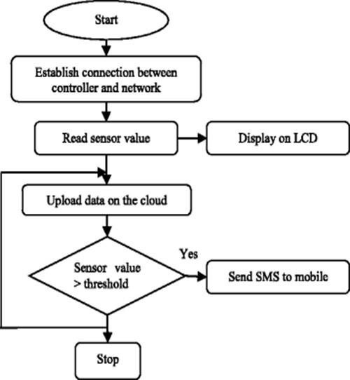

Fig 5.1.1 flowchart for Air Pollution Monitoring System

**BLOCK DIAGRAM**

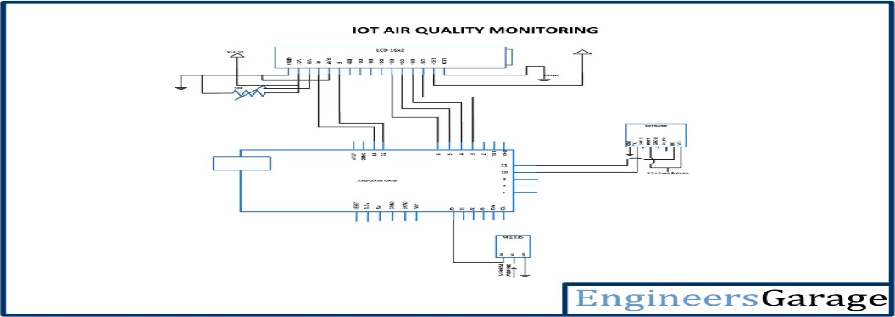

Fig 5.1.2 block diagram for Air Pollution Monitoring System

#### **6.1 UPLOADING CODE TO AURDINO**

Step 1 − First you must have your Arduino board (you can choose your favorite board) and a USB cable. In case you use Arduino UNO, Arduino Duemilanove, Nano, Arduino Mega 2560, or Diecimila, you will need a standard USB cable (A plug to B plug), the kind you would connect to a USB printer as shown in the following image.

In case you use Arduino Nano, you will need an A to Mini-B cable instead as shown in the following image.

Step 2 **−** Download Arduino IDE Software**.**

You can get different versions of Arduino IDE from the [Download page o](https://www.arduino.cc/en/Main/Software)n the Arduino Official website.

You must select your software, which is compatible with your operating system (Windows, IOS, or Linux). After your file download is complete, unzip the file.

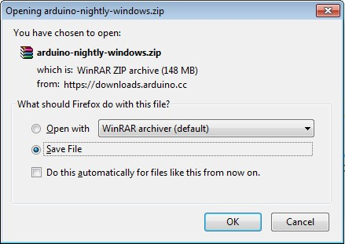

Step 3 − Power up your board**.**

The Arduino Uno, Mega, Duemilanove and Arduino Nano automatically draw power from either, the USB connection to the computer or an external power supply. If you are using an Arduino Diecimila, you have to make sure that the board is configured to draw power from the USB connection. The power source is selected with a jumper, a small piece of plastic that fits onto two of the three pins between the USB and power jacks. Check that it is on the two pins closest to the USB port.

Connect the Arduino board to your computer using the USB cable. The green power LED (labeled PWR) should glow.

Step 4 − Launch Arduino IDE**.**

After your Arduino IDE software is downloaded, you need to unzip the folder. Inside the folder, you can find the application icon with an infinity label (application.exe). Double-click the icon to start the IDE.

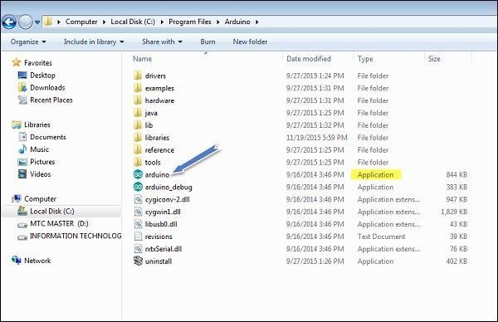

Step 5 − Open your first project.

Once the software starts, you have two options −

* Create a new project.
* Open an existing project example.

To create a new project, select File → **New**.

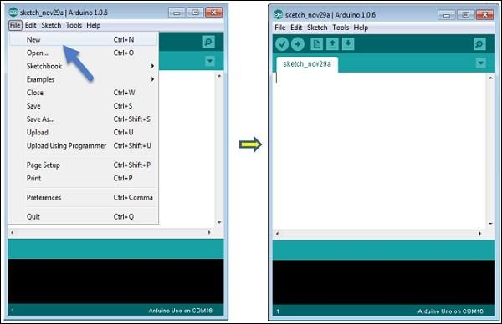

To open an existing project example, select File → Example → Basics → Blink.

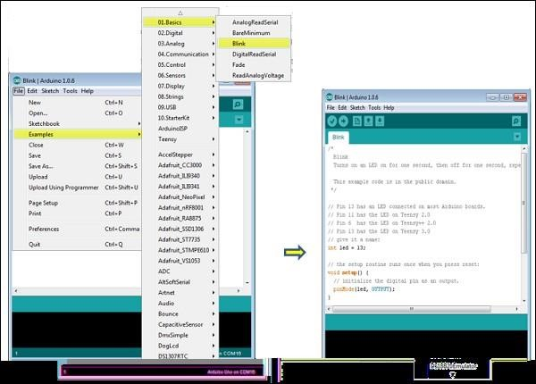

Here, we are selecting just one of the examples with the name **Blink**. It turns the LED on and off with some time delay. You can select any other example from the list.

Step 6 − Select your Arduino board.

To avoid any error while uploading your program to the board, you must select the correct Arduino board name, which matches with the board connected to your computer.

Go to Tools → Board and select your board.

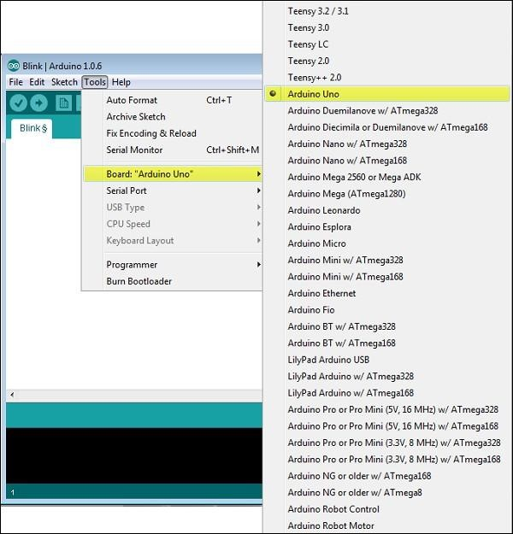

Here, we have selected Arduino Uno board according to our tutorial, but you must select the name matching the board that you are using.

Step 7 − Select your serial port**.**

Select the serial device of the Arduino board. Go to Tools → Serial Port menu. This is likely to be COM3 or higher (COM1 and COM2 are usually reserved for hardware serial ports). To find out, you can disconnect your Arduino board and re-open the menu, the entry that disappears should be of the Arduino board. Reconnect the board and select that serial port.

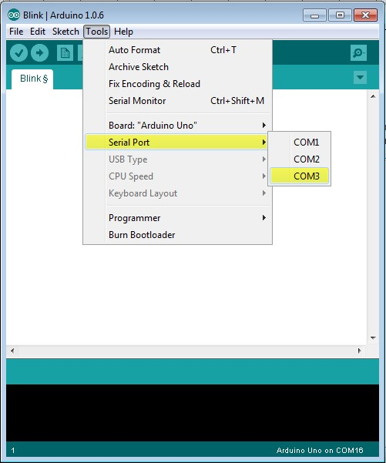

Step 8 − Upload the program to your board**.**

Before explaining how we can upload our program to the board, we must demonstrate the function of each symbol appearing in the Arduino IDE toolbar.

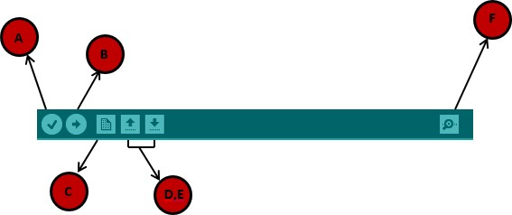

1. − Used to check if there is any compilation error.
2. − Used to upload a program to the Arduino board.
3. − Shortcut used to create a new sketch.
4. − Used to directly open one of the example sketches.
5. − Used to save your sketch.
6. − Serial monitor used to receive serial data from the board and send the serial data to the board.

Now, simply click the "Upload" button in the environment. Wait a few seconds; you will see the RX and TX LEDs on the board, flashing. If the upload is successful, the message "Done uploading" will appear in the status bar.

#### **6.2 HARDWARE CONNECTIONS**

First of all, we will connect the **ESP8266 with the Arduino**. ESP8266 runs on 3.3V and if you will give it 5V from the Arduino then it won’t work properly and it may get damage. Connect the VCC and the CH_PD to the 3.3V pin of Arduino. The RX pin of ESP8266 works on 3.3V and it will not communicate with the Arduino when we will connect it directly to the Arduino. So, we will have to make a voltage divider for it which will convert the 5V *into 3*.3V. This can be done by connecting three resistors in series like we did in the circuit. Connect the TX pin of the ESP8266 to the pin 10 of the Arduino and the RX pin of the esp8266 to the pin 9 of Arduino through the resistors.

ESP8266 Wi-Fi module gives your projects access to Wi-Fi or internet.

Then we will connect the **MQ135 sensor with the Arduino**. Connect the VCC and the ground pin of the sensor to the 5V and ground of the Arduino and the Analog pin of sensor to the A0 of the Arduino.

Connect a buzzer to the pin 8 of the Arduino which will start to beep when the condition becomes true.

The connections of the LCD are as follows

Connect pin 1 (VEE) to the ground. Connect pin 2 (VDD or VCC) to the 5V.

Connect pin 3 (V0) to the middle pin of the 10K potentiometer and connect the other two ends of the potentiometer to the VCC and the GND. The potentiometer is used to control the screen contrast of the LCD. Potentiometer of values other than 10K will work too.

Connect pin 4 (RS) to the pin 12 of the Arduino.

Connect pin 5 (Read/Write) to the ground of Arduino. This pin is not often used so we will connect it to the ground.

Connect pin 6 (E) to the pin 11 of the Arduino. The RS and E pin are the control pins which are used to send data and characters.

The following four pins are data pins which are used to communicate with the Arduino.

Connect pin 11 (D4) to pin 5 of Arduino. Connect pin 12 (D5) to pin 4 of Arduino. Connect pin 13 (D6) to pin 3 of Arduino. Connect pin 14 (D7) to pin 2 of Arduino.

Connect pin 15 to the VCC through the 220-ohm resistor. The resistor will be used to set the back light brightness. Larger values will make the back light much darker.

Connect pin 16 to the Ground.

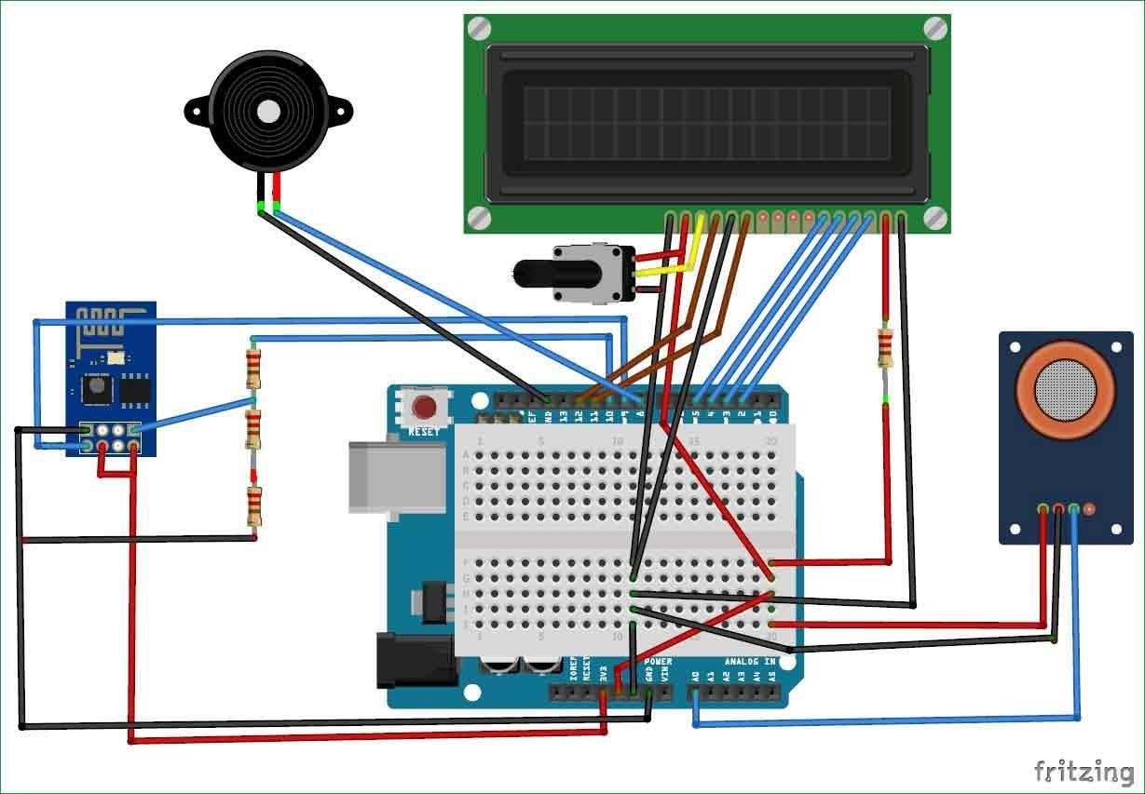

Fig 6.2.1 Circuit Diagram for Air Pollution Monitoring System

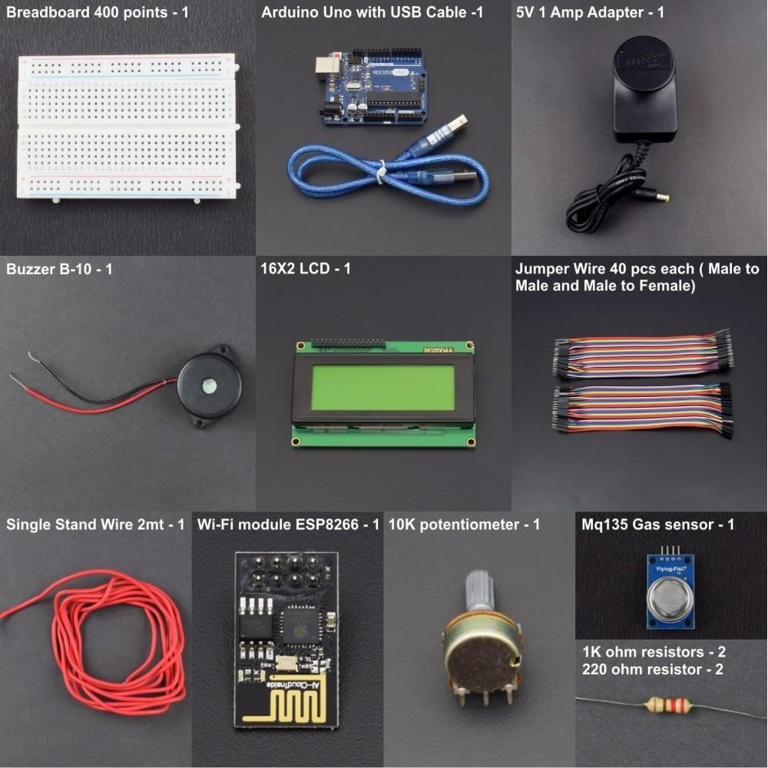

Fig 6.2.2 components for Air Pollution Monitoring System

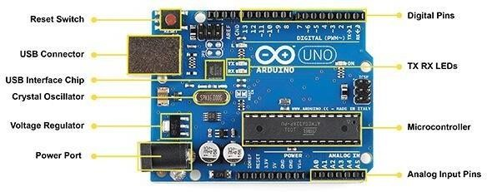

Fig 6.2.3 Arduino Uno and its labelling

ARDUINO UNO R3 MICROCONTROLLER It is the most flexible hardware platform used based on ATmega328P which can be programmed according to the function where it is to be used. It has 6 analog inputs, 14 digital input/output pins (6 pins of these can be used as PWM outputs) , a USB connection, a 16 MHz quartz crystal, SPI, serial interface, a reset button, a power jack and an ICSP header as shown in Fig.2. The Arduino microcontroller is not only for technical audience but is intended for designers and artists as well because of its focus to usability based on its design which helps to achieve the intended goal. It is the primary component of the framework. In addition, it is an open-source microcontroller device with easily accessible software/hardware platform and is compatible with many sensors available.

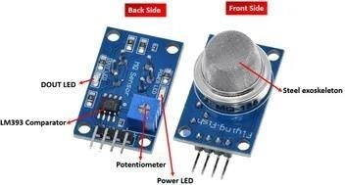

Fig 6.2.4 mq135 gas sensor and its labelling

MQ135 SENSOR The Sensitive material used in MQ135 sensor is SnO2. The conductivity of this material is lower in clean air. The sensor conductivity increases with the increasing concentration of target pollution gas. MQ135 can monitor different kinds of toxic gases such as sulphide, ammonia gas, benzene series steam and CO2. The detection range is 10-10,000 ppm with the voltage rate of about 5.0V±0.1V AC or DC. The important features are long life span, low cost, simple driver circuit and good sensitivity to toxic gases.

MQ 135 gas sensor is widely used in industrial gas alarm, portable gas detector and domestic gas alarm as shown in Fig.1. MQ-135 is used for monitoring CO2 in air. Specifications of MQ-135 gas sensor Wide detecting scope Fast response and High sensitivity, Stable and long-life Simple drive circuit, used in air quality control equipment for buildings/offices, is suitable for detecting of NH3, NOx, alcohol,

Benzene, smoke, CO2, etc., Size: 35mm x 22mm x 23mm (length x width x height),

Working voltage: DC 5 V, Signal output instruction. Dual signal output (analog output, and high/low digital output) 0 ~ 4.2V analog output voltage, the higher the concentration the higher the voltage.

LCD Display 16x2 LCD (Liquid Crystal Display) screen is an electronic display module and find a wide range of applications. A 16x2 LCD display is very basic module and is very commonly used in various devices and circuits. A 16x2 LCD means it can display 16 characters per line and there are 2 such lines. In this LCD each character is displayed in 5x7 pixel matrix. This LCD has two registers, namely, Command and Data. The command register stores the command instructions given to the LCD. The data register stores the data to be displayed on the LCD.

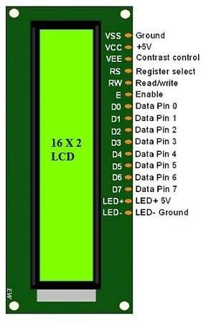

**7.CODE**

#include<LiquidCrystal.h>

const int rs=12, en=11, d4=5, d5=4, d6=3, d7=2; Liquid Crystal lcd (rs, en, d4, d5, d6, d7);

int buz=8; int led=9;

const int aqsensor=A0;

int threshold=250;

void setup (){

pinMode (buz, OUTPUT); pinMode (led, OUTPUT);

pinMode (aqsensor, INPUT); Serial.begin(9600);

lcd. clear ();

lcd. begin (16,2);}

void loop (){

int ppm=analogRead(aqsensor);

Serial.print("Air Quality: "); Serial.println(ppm);

lcd. setCursor (0,0);

lcd. Print ("Air Quality: "); lcd. Print(ppm);

if (ppm > threshold){

lcd. setCursor (1,1);

lcd. Print ("AQ LevelHIGH");

tone(led,1000,200);

digital Write (buz, HIGH);}

else{

digitalWrite (led, LOW); digitalWrite (buz, LOW);

lcd. setCursor (1,1);

lcd.Print ("AQ Level Good");}

delay (500);}

**8. TESTING**

The MQ135 sensor can sense NH3, NOx, alcohol, Benzene, smoke, CO2 and some other gases, so it is perfect gas sensor for our **Air Quality Monitoring Project**. When we will connect it to Arduino then it will sense the gases, and we will get the Pollution level in PPM (parts per million). MQ135 gas sensor gives the output in form of voltage levels and we need to convert it into PPM. So, for converting the output in PPM, here we have used a library for MQ135 sensor, it is explained in detail in “Code

Explanation” section below.

Sensor was giving us value of 90 when there was no gas near it and the safe level of air quality is 350 PPM and it should not exceed 1000 PPM. When it exceeds the limit of 1000 PPM, then it starts cause Headaches, sleepiness and stagnant, stale, stuffy air and if exceeds beyond 2000 PPM then it can cause increased heart rate and many other diseases.

When the value will be less than 1000 PPM, then the LCD and webpage will display “Fresh Air”. Whenever the value will increase 1000 PPM, then the buzzer will start beeping and the LCD and webpage will display “Poor Air, Open Windows”. If it will increase 2000 then the buzzer will keep beeping and the LCD and webpage will display “Danger! Move to fresh Air”.

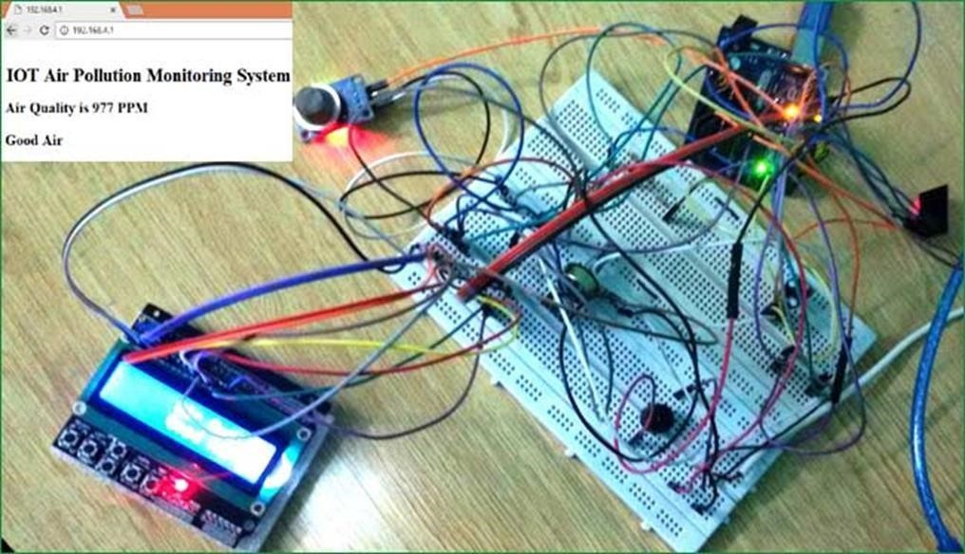

**CONCLUSION**

This system includes the sensors that detect the parameters causing pollution. The sensors are carbon dioxide sensor. Whenever there is an increase in the level of these parameters the sensor senses the situation and an alarm or indication is given. The message is displayed in the LCD display. If the authority of the industry does not take any actions to minimize the emission, then the system takes certain actions to this. If carbon-dioxide rises

**FUTURE SCOPE**

* In future, this project can be extended in real time implementations of urban cities. This project can also be used in the following domains:
* This project can be used in Homes and Offices to notify the people if the air quality in their living space drops below a certain point so they can take precautions.
* This can be used in Industries to notify the workers if there is a gas leak or the working conditions as suitable.
* This can be used by the fire fighters for remotely sensing if there is a gas leak in the neighborhood. This project can be used in hospitals, clinics and ICU units to monitor the air quality.
* This can also be used in research and agriculture purpose.

**BIBILOGRAPHY**

* A Boubrima, W Bechkit, and H Rivano 2017 A new WSN deployment approach for air pollution monitoring, 2017 14th IEEE Annu. Consum. Commun. Netw. Conf. CCNC 2017, pp. 455–460
* B Bathiya 2016 Air Pollution Monitoring Using Wireless Sensor Network 2016 IEEE International WIE Conference on Electrical and Computer Engineering (WIECON-ECE) 19-21 December 2016
* A Škraba, A Koložvari, D Kofjač, R Stojanović, V Stanovov, and E Semenkin 2016 Streaming pulse data to the cloud with bluetooth le or NODEMCU ESP8266 2016 5th Mediterr. Conf. Embed. Comput. MECO 2016 - Incl. ECyPS 2016, BIOENG.MED 2016, MECO Student Chall. 2016, pp. 428–431,

2016

* K Keshamoni and S Hemanth 2017 Smart gas level monitoring, booking & gas leakage detector over iot Proc. - 7th IEEE Int. Adv. Comput. Conf. IACC 2017, pp. 330–332
* D Spirjakin, A M Baranov, and V Sleptsov 2015 Design of smart dust sensor node for combustible gas
* Harsh N. Shah, Zishan Khan, Abbas Ali Merchant, MoinMoghal, Aamir Shaikh, PritiRane published the paper on “IOT BASED AIR POLLUTION MONITORING SYSTEM” International Journal of Scientific & Engineering Research Volume 9, Issue 2, February-2018ISSN 2229-5518.
* T. MANDAVA, S. CHEN, O. ISAFIADE, A. BAGULA ISAT Laboratory, Department of Computer

Science published the paper on “An IoT Middleware for Air Pollution Monitoring in Smart Cities: A

Situation Recognition Model” IST-Africa 2018 Conference Proceedings Paul Cunningham and Miriam Cunningham (Eds) IIMC International Information Management Corporation, 2018. ISBN: 978-1- 905824-59-5.

* Sarun Duangsuwany, Aekarong Takarnyy, and PunyawiJamjareegulgarnz published the paper on “A Development on Air Pollution Detection Sensors based on NB-IoT Network for Smart Cities”.
* Vidit Laijawala, Moin Masurkar, Rohit Khandekar published the paper on “Air Quality Monitoring

System” K J Somaiya Institute of Engineering & Information Technology University of Mumbai, India 2015.